Output
--- Step 1: Put-Call Parity and Option Pricing ---

# Q1: Put-call parity holds for European options: C + K*exp(-r*T) = P + S0.
LHS (C + K*e^(-rT)) = 103.3718
RHS (P + S0) = 103.3718
Difference = 0.000000

# Q2: Solve for C: C = P + S0 - K*exp(-r*T).
Calculated Call Price C: 4.6140
Directly Priced Call C: 4.6140
Difference: 0.000000

# Q3: Solve for P: P = C - S0 + K*exp(-r*T).
Calculated Put Price P: 3.3718
Directly Priced Put P: 3.3718
Difference: 0.000000

# Q4: For American options strict equality fails due to early exercise; only inequalities hold.
American Options 'Parity' Check:
LHS (C_A + K*e^(-rT)) = 103.3718
RHS (P_A + S0) = 103.4793
Difference = 0.107563

# Q5: Price ATM European call and put (binomial)
Steps: 1000
European Call: 4.61
European Put : 3.37

# Q6: European Delta at t=0 (binomial)
Call Delta: 0.5694
Put Delta: -0.4306

# Q7: Vega (European) via σ bump 20% -> 25%
Call: 4.61 -> 5.60, Vega ≈ 19.6631
Put : 3.37 -> 4.35, Vega ≈ 19.6631

# Q8: Price ATM American call and put (binomial)
American Call: 4.61
American Put : 3.48

# Q9: American Delta at t=0 (binomial)
Call Delta: 0.5694
Put Delta: -0.4495

# Q10: Vega (American) via σ bump 20% -> 25%
Call: 4.61 -> 5.60, Vega ≈ 19.6631
Put : 3.48 -> 4.46, Vega ≈ 19.5986

# Q11: European put–call parity check
LHS (C + K e^(-rT)) = 103.3718
RHS (P + S0) = 103.3718
Difference = 0.000000

# Q12: American 'parity' equality fails
LHS (C_A + K e^(-rT)) = 103.3718
RHS (P_A + S0) = 103.4793
Difference = 0.107563

# Q13: Confirm C_E <= C_A (no dividends) -> typically equal.
Diff (A−E) for Call = 0.000000
# Q14: Confirm P_E <= P_A.
Diff (A−E) for Put = 0.107563

--- Step 2: Trinomial Tree and Strike Price Analysis ---

# Q15: Price 5 European CALLs using a trinomial tree
Strike Moneyness European Call
90 Deep OTM 10.37
95 OTM 6.63
100 ATM 3.81
105 ITM 1.96
110 Deep ITM 0.90

# Q16: Price 5 European PUTs using a trinomial tree
Strike Moneyness European Put
90 Deep OTM 0.74
95 OTM 1.94
100 ATM 4.06
105 ITM 7.14
110 Deep ITM 11.02

# Q17: Price 5 American CALLs using a trinomial tree
Strike Moneyness American Call
90 Deep OTM 10.50
95 OTM 6.69
100 ATM 3.84
105 ITM 1.97
110 Deep ITM 0.90

# Q18: Price 5 American PUTs using a trinomial tree
Strike Moneyness American Put
90 Deep OTM 0.74
95 OTM 1.94
100 ATM 4.06
105 ITM 7.14
110 Deep ITM 11.02

# Q19: Graph data — option value vs S0 (European, K=100)
Arrays prepared: val_call_vs_S, val_put_vs_S
Length: 51 | Sample first 5 call values: [0. 0. 0. 0. 0.]

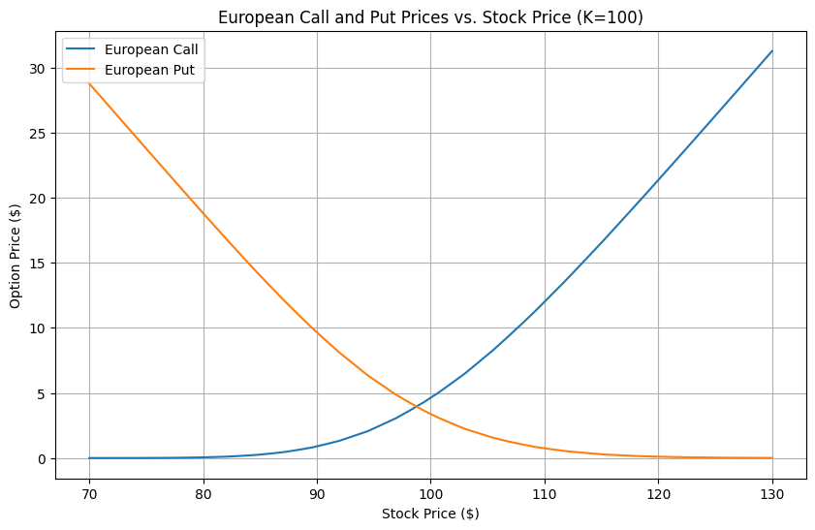
# Q20: Graph data — Delta vs S0 (European, K=100)
Arrays prepared: delta_call_vs_S, delta_put_vs_S
Length: 51 | Sample first 5 call deltas: [0. 0. 0. 0. 0.]

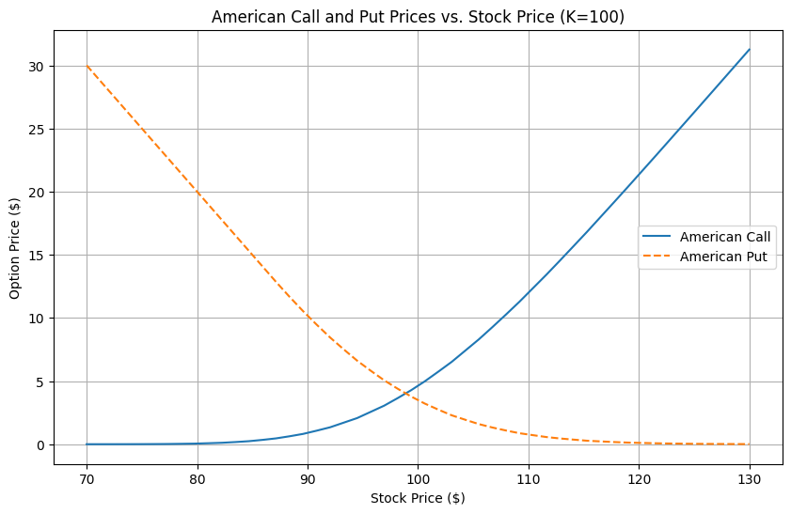
# Q21: Graph data — option value vs K (European, S0=100)
Arrays prepared: val_call_vs_K, val_put_vs_K
K values: [ 90 95 100 105 110] | Call values: [11.6717 7.7176 4.61 2.4819 1.1918]

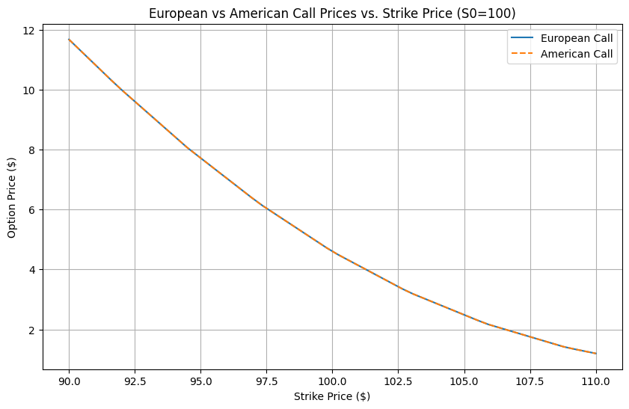
# Q22: Graph data — Delta vs K (European, S0=100)
Arrays prepared: delta_call_vs_K, delta_put_vs_K
K values: [ 90 95 100 105 110] | Call deltas: [0.8903 0.7541 0.5694 0.3771 0.218 ]

--- Q19-22: Generating Graphs ---
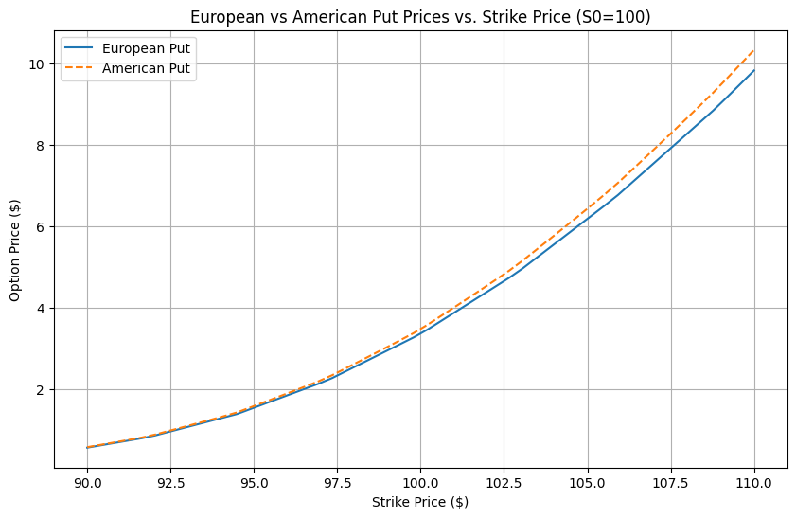
# Q23: Check put–call parity for European options (trinomial)
Strike | LHS (C + K e^{-rT}) | RHS (P + S0) | |Diff|
90 | 99.2489 | 100.7377 | 1.4888
95 | 100.4473 | 101.9361 | 1.4888
100 | 102.5680 | 104.0568 | 1.4888
105 | 105.6541 | 107.1429 | 1.4888
110 | 109.5308 | 111.0196 | 1.4888

# Q24: American 'parity' equality fails (trinomial)
Strike | LHS (C_A + K e^{-rT}) | RHS (P_A + S0) | |Diff|
90 | 99.3812 | 100.7377 | 1.3566
95 | 100.5089 | 101.9362 | 1.4272
100 | 102.5946 | 104.0572 | 1.4626
105 | 105.6646 | 107.1444 | 1.4798
110 | 109.5346 | 111.0244 | 1.4898

--- Step 3: Real-World Questions ---

# Q25: 3-step dynamic Delta hedging (European Put, binomial)
Stock tree (rows=#downs, cols=time):
[[180. 199.34139817 220.76107236 244.48233791]
[ 0. 162.53523 180. 199.34139817]
[ 0. 0. 146.76500551 162.53523 ]
[ 0. 0. 0. 132.5249107 ]]

European put values (same indexing):
[[13.8223851 5.01268419 0. 0. ]
[ 0. 22.4055917 9.87779048 0. ]
[ 0. 0. 34.62933781 19.46477 ]
[ 0. 0. 0. 49.4750893 ]]

Delta at each node (same indexing, last col empty):
[[-0.47255415 -0.24233392 0. ]
[ 0. -0.74474354 -0.52884533]
[ 0. 0. -1. ]]

# Q26: 25-step American Put — price and pathwise Δ idea
American Put Price (25-step binomial): 13.04
For hedging, compute Δ at each node similarly to Q25, but with early exercise check.

# Q27: Asian ATM Put via Monte Carlo (arithmetic average)
Asian ATM Put Price (MC): 7.75
(Averaging reduces effective volatility -> typically cheaper; smoother hedging.)

Final Summary: European vs. American (Trinomial, all strikes)
Strike Eur Call Am Call Eur Put Am Put
90 10.37 10.50 0.74 0.74
95 6.63 6.69 1.94 1.94
100 3.81 3.84 4.06 4.06
105 1.96 1.97 7.14 7.14
110 0.90 0.90 11.02 11.02
​

